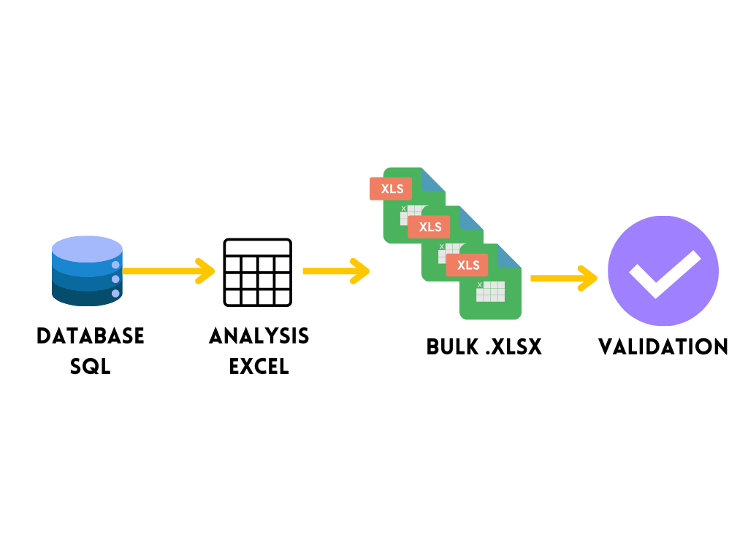

For this project, starting from a SQL database and generating several individual files according to different selection criteria was necessary. Due to the large number of files required, a macro was implemented in Excel that extracts the corresponding information and saves it in individual files with specific names. Finally, the generated data was automatically validated by means of Power Query.

**Here are the questions I was interested in answering**

How do you generate multiple individual files from an SQL database?

What selection criteria are used to generate these files?

How is the generated data automatically validated?

**I took the following steps to create my analysis**

Extract the information from the database in SQL to Power Query/Excel

Implement a macro in Excel to generate the individual files according to the selection criteria.

Name the generated files in a specific way.

Automatically validate the generated data using Power Query.

**Here are my takeaways**

The Excel macro allows the efficient generation of multiple individual files.

The extracted information is saved with specific names.

Power Query ensures automatic validation of the generated data.